Laboratory work #3
Ishutin Nikolay
3.2 Database Systems. Relational Model & Keys
Part 1: Key Identification Exercises
Task 1.1: Superkey and Candidate Key Analysis
Relation A: Staff
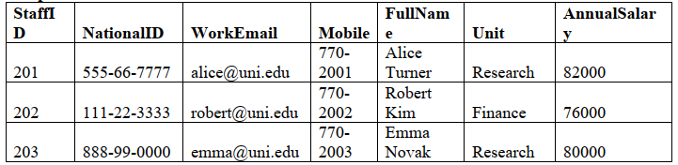
1. List at least 4 different superkeys for the Staff relation (show the attribute sets).

2. Identify all candidate keys.
3. Which candidate key would you choose as the primary key and why? Provide justification
(uniqueness, stability, privacy, etc.).
4. Could two staff members share the same mobile number? Explain whether the given data
supports that and what business rule you would choose.

